

American International University - Bangladesh

CSC 3222: Web Technologies

CO1.1 and CO2.1 Evaluation

Project Report

Summer 20-21

Project Title: E-Shop Management System

Section: J

|  |  |
| --- | --- |
| Student Name | Student Id |
| Hossain, Md Shakhwat | 17-35332-2 |
| Islam, Sadia | 18-36880-1 |
| Paul, Avijit | 18-37556-1 |
| Shovo, Ibrahim Khan | 18-36161-1 |

**Introduction:**

An E-shop management system assists shop owners in keeping track of their sales and purchases, variety of items, stocks, customers, etc. Historically, with a paper-based system shop owners had to keep track of all relevant paperwork. And managing accounting on a page is extremely difficult and time consuming. Our system will convert all of these hectic procedures to very simple. Users can input their details and all the hectic procedures will be handled by our automated system. This will be very useful to all the customers and shop owners. That is why we are undertaking this project.

**Background Study**

There are some E-Shop businesses that are already created based on this idea. Daraz, Evaly, Pickaboo.com are some great examples of E-Shop. Among them we want to focus on Tech Land as we want to build our system which matches the idea of TechLand’s most. Tech Land is a reliable computer and computer parts retail store in Bangladesh. In 2016, Tech Land was established, and its motto was Best Price, Best Service, and Authentic Product. Tech Land offers the widest and most customizable selection of technology products, taking into consideration every customer's individual preferences.This site is easy to access. It's considered to be the most popular E-Commerce for buying electronic goods. [This is the website of Tech Land: <*https://www.techlandbd.com/*](https://www.techlandbd.com/)*>*

**Requirement Analysis:**

1. **User Category:**

There are 4-types of Users here. They are:

* Admin
* Manager
* Seller
* Customer

1. **Feature List:**

In this project the “**Admin**” has the following features:

* Log in / Sign In
* Registration / Sign Up
* View Profile
* Edit profile
* Manage Manager and employee/seller
* Add employee
* Remove employee
* Manage Products(Add/update/delete)
* Check complain
* Can see customer details
* Can login as all user

In this project the “**Manager**” has the following features:

* Log in / Sign In
* Registration / Sign Up
* View Profile
* Edit profile
* Manage employee/seller and customer
* Add employee
* Remove employee
* Manage Products(Add/update/delete)
* Check complain
* Can login as all user
* Can see customer details

In this project the “**Seller**” has the following features:

* Log in / Sign In
* Registration/ Sign Up via authorization
* View Profile
* Edit profile
* Add Products
* Search Product
* Update Product
* Delete Product
* Summary of all added products
* Ordered products from customers

In this project the user named “**Customer**” has the following features:

* Log in / Sign In
* Registration / Sign Up
* View profile
* Edit profile information
* Browse products
* Search products
* Add to cart
* View cart
* Order product
* History of previously ordered products
* Contact us window

**Design:**

An Entity diagram of E-shop management system: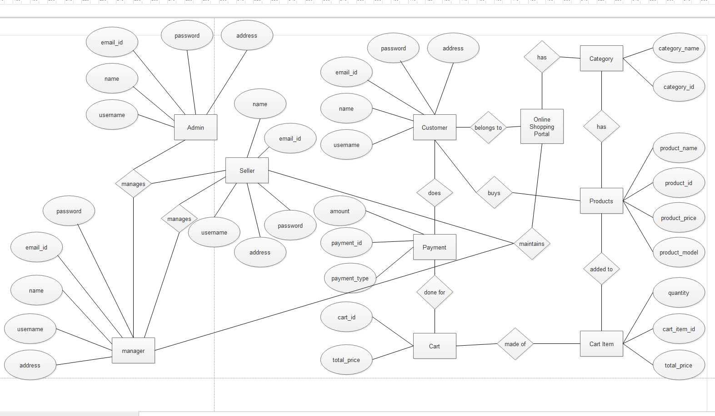

**Tools Used:**

To develop this project, we have used the following:

* Personal computer
* Code editor (MS Visual Studio Code/Sublime Text)
* XAMPP
* Browser (Chrome/Firefox etc.)
* Dia for ER diagram

**System Images against the Specification:**

Customer:

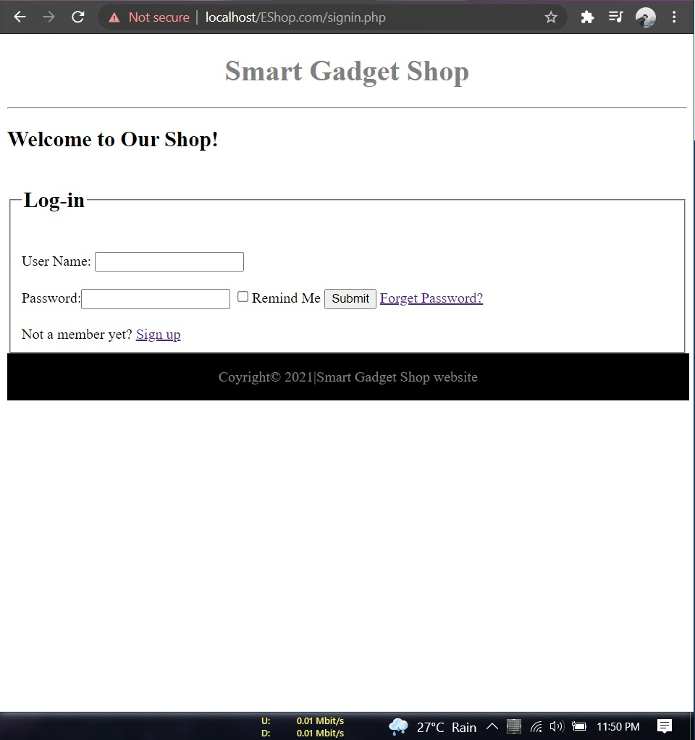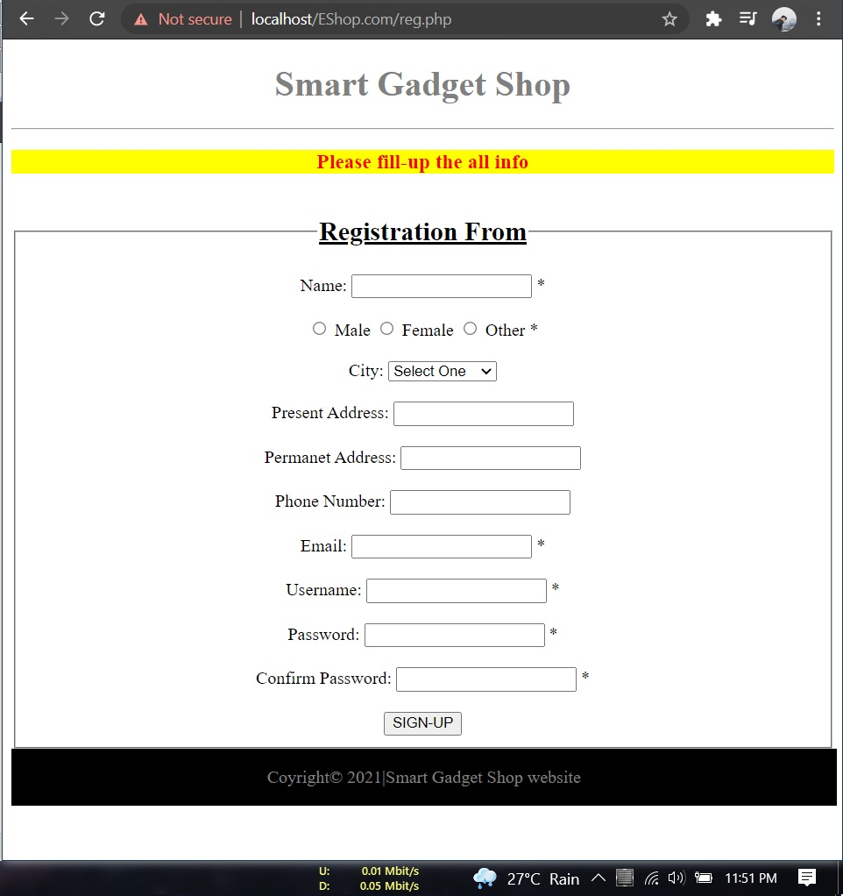

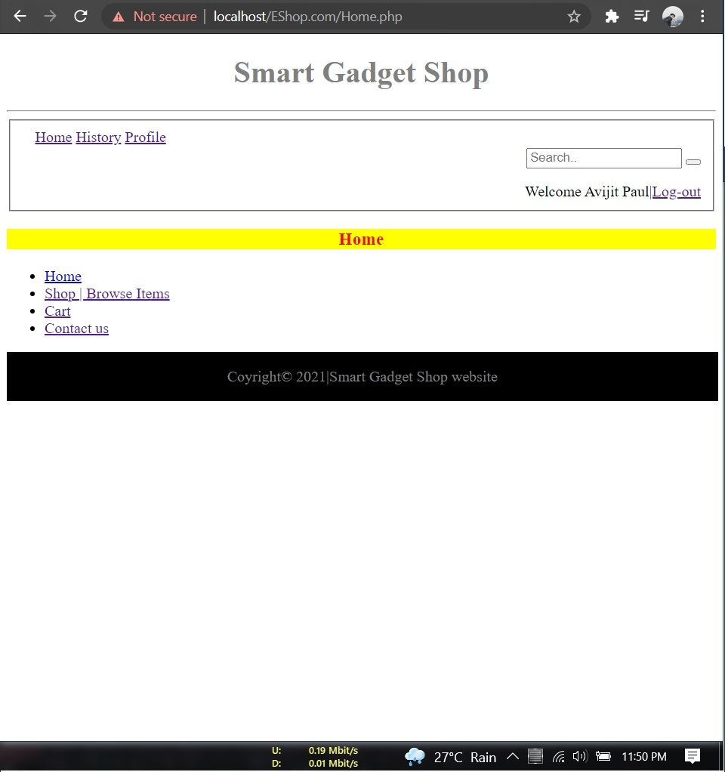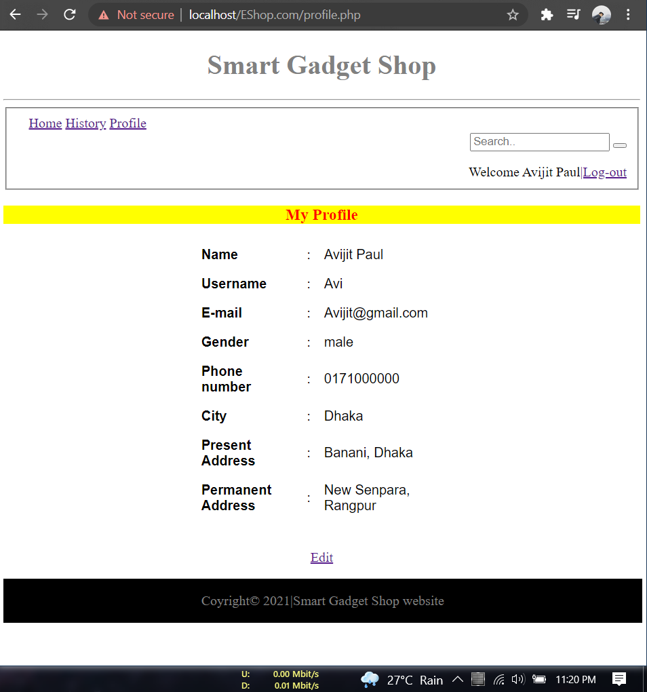

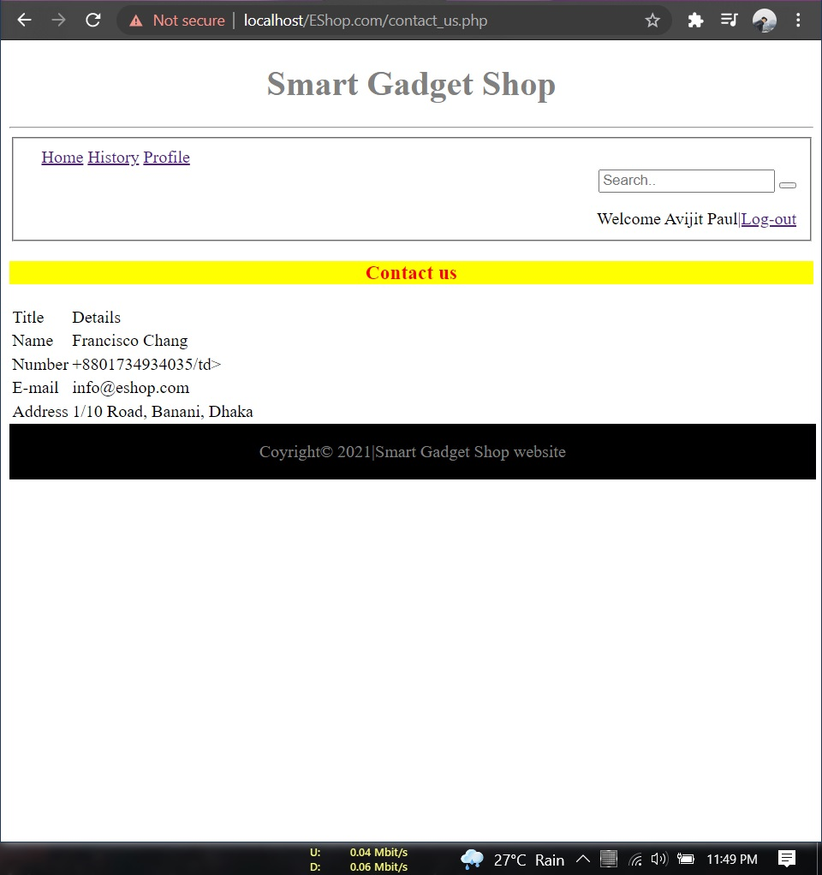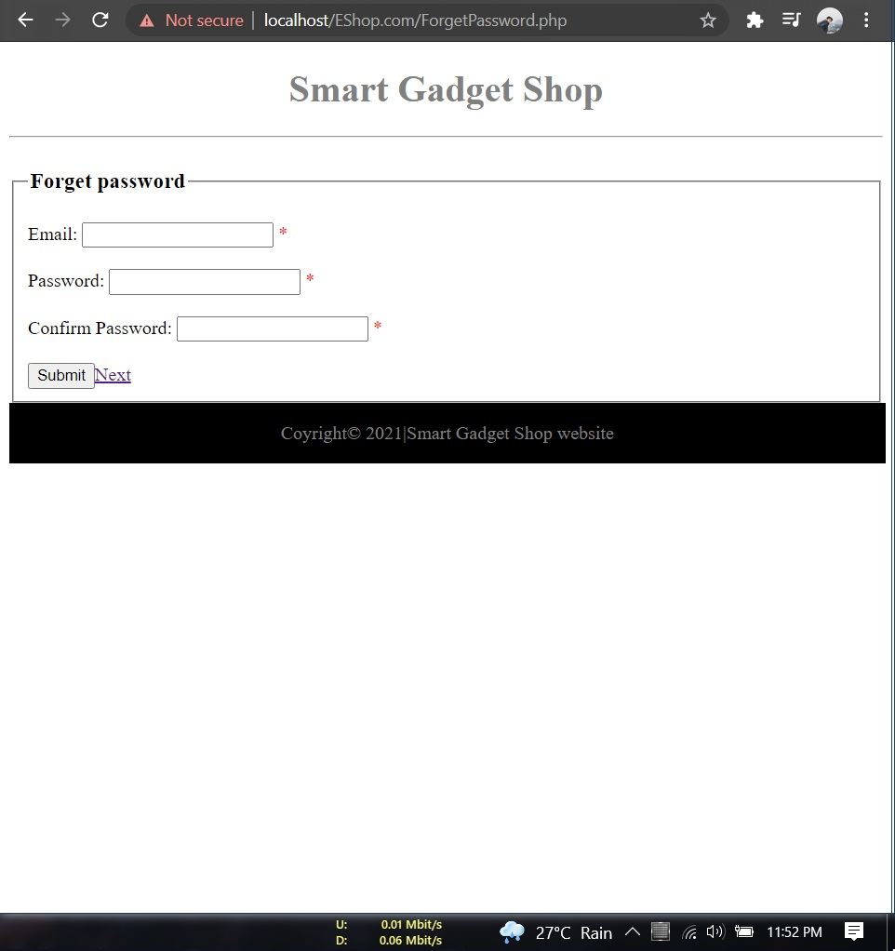

Admin/Manager:

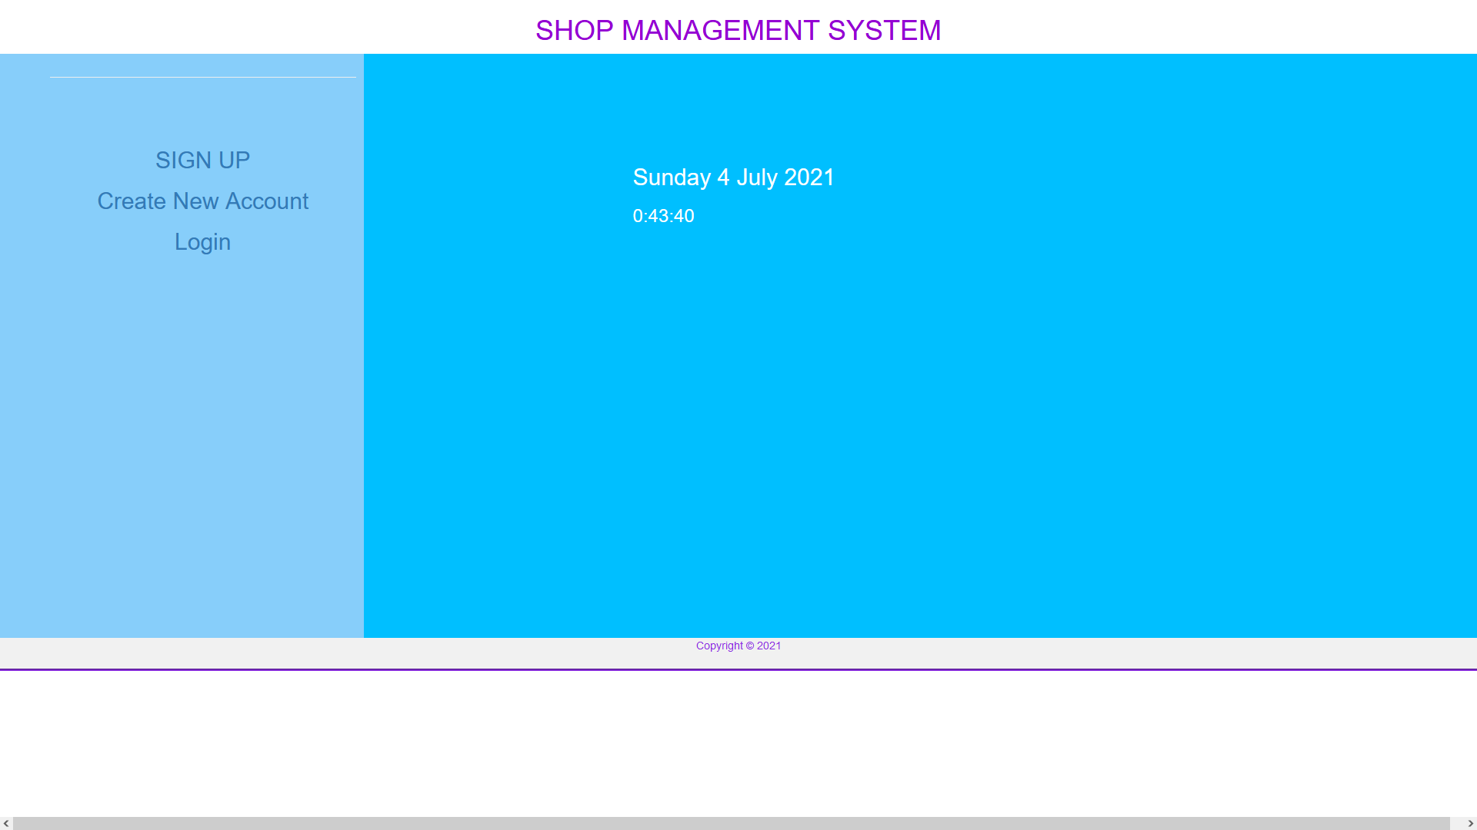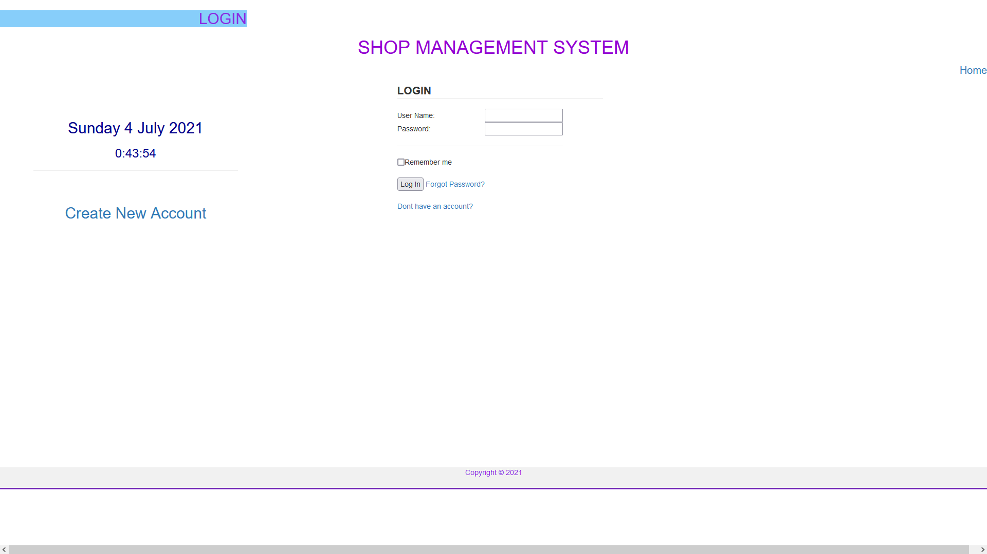

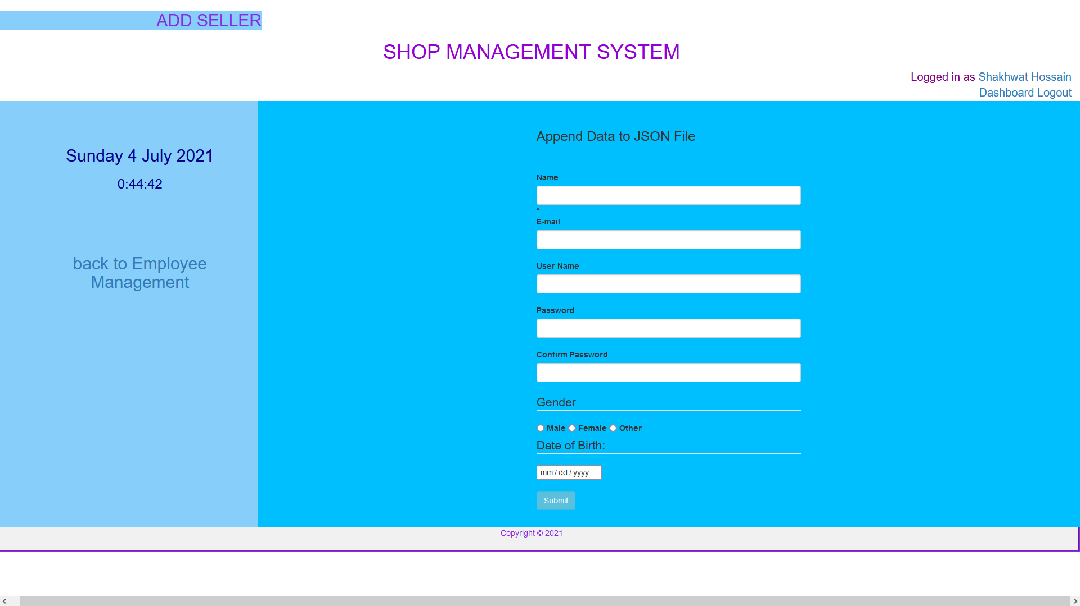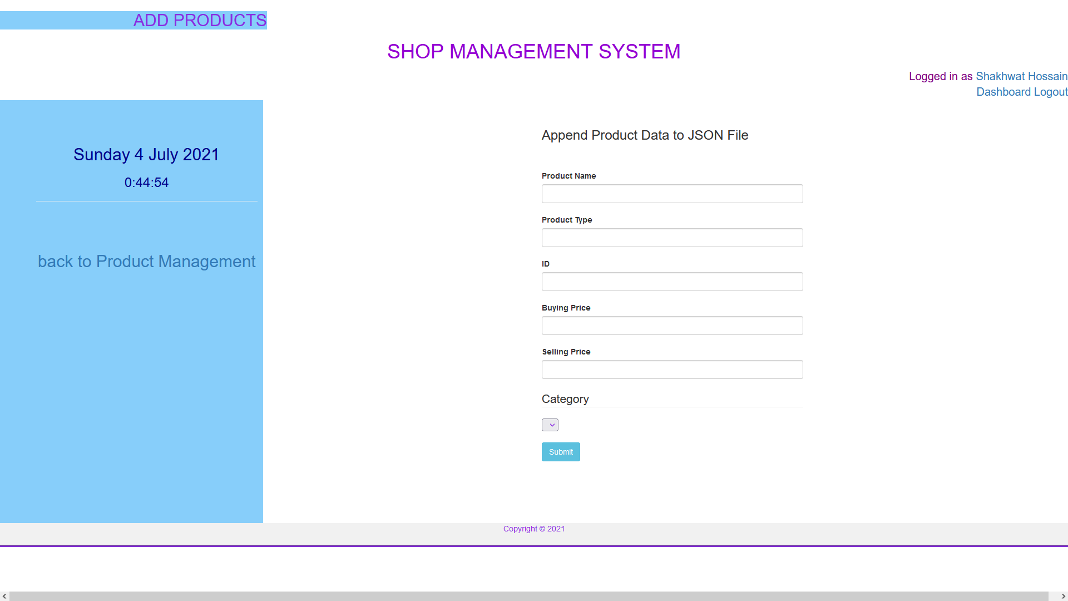

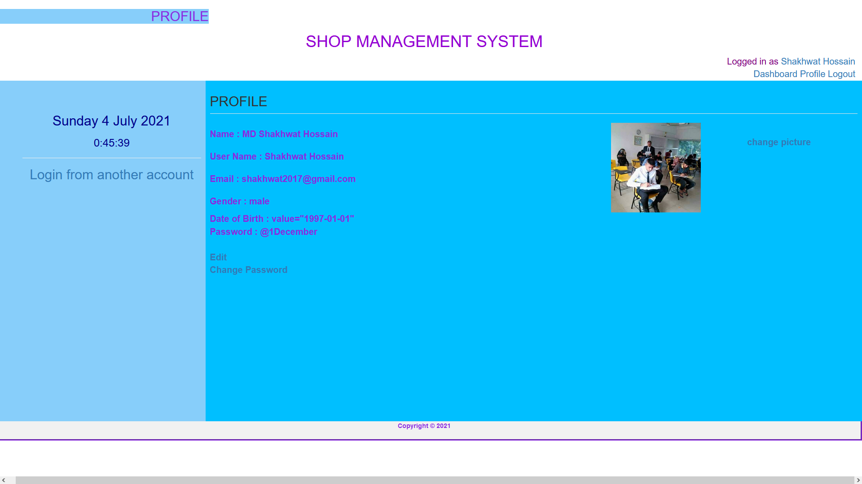

Seller:

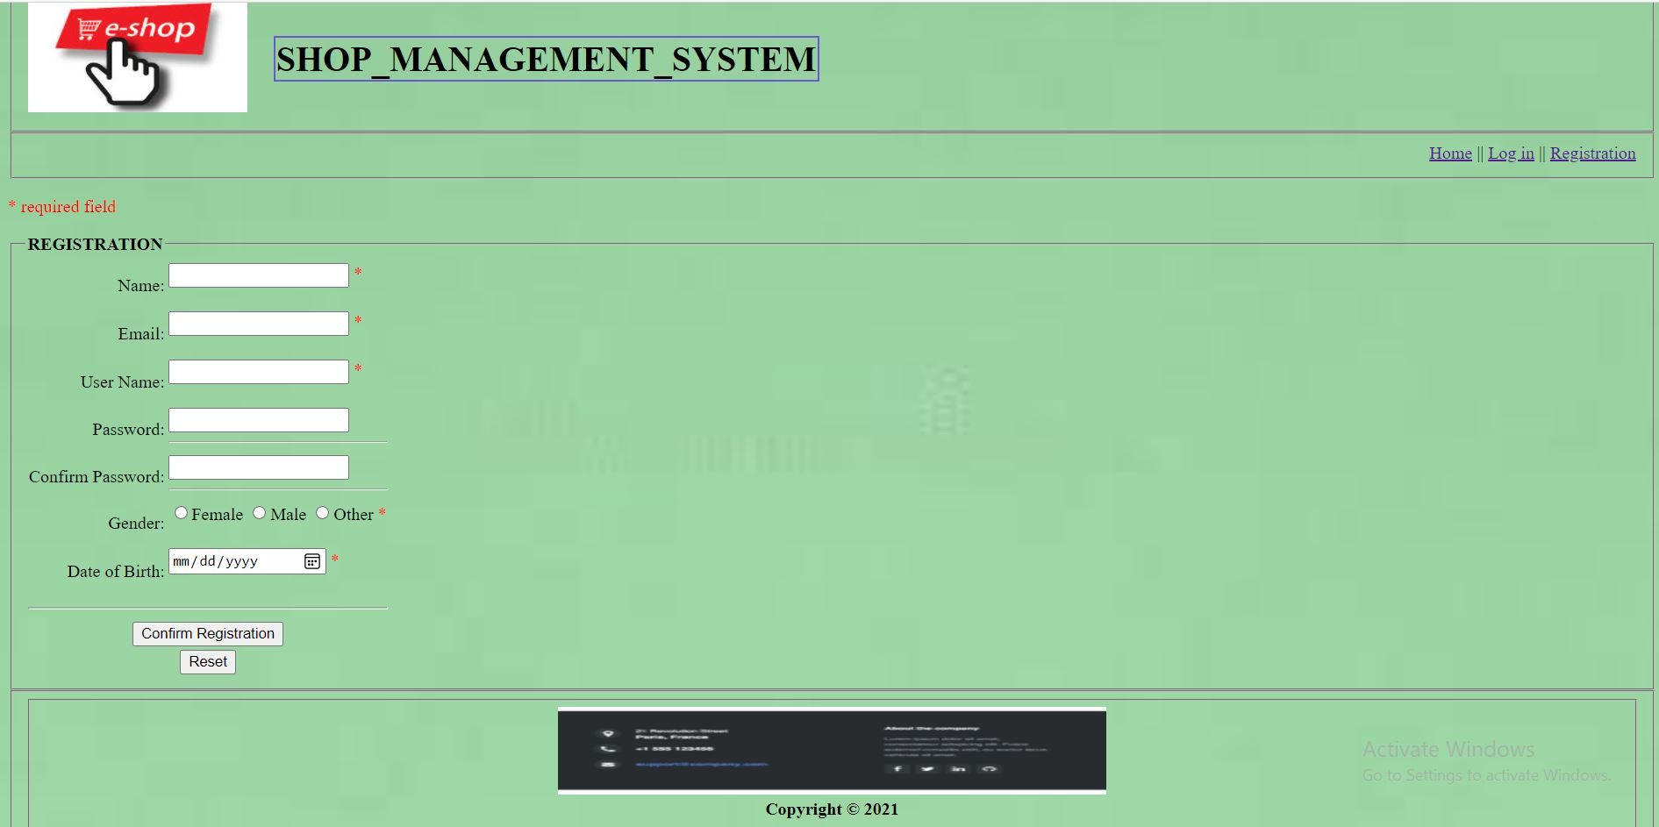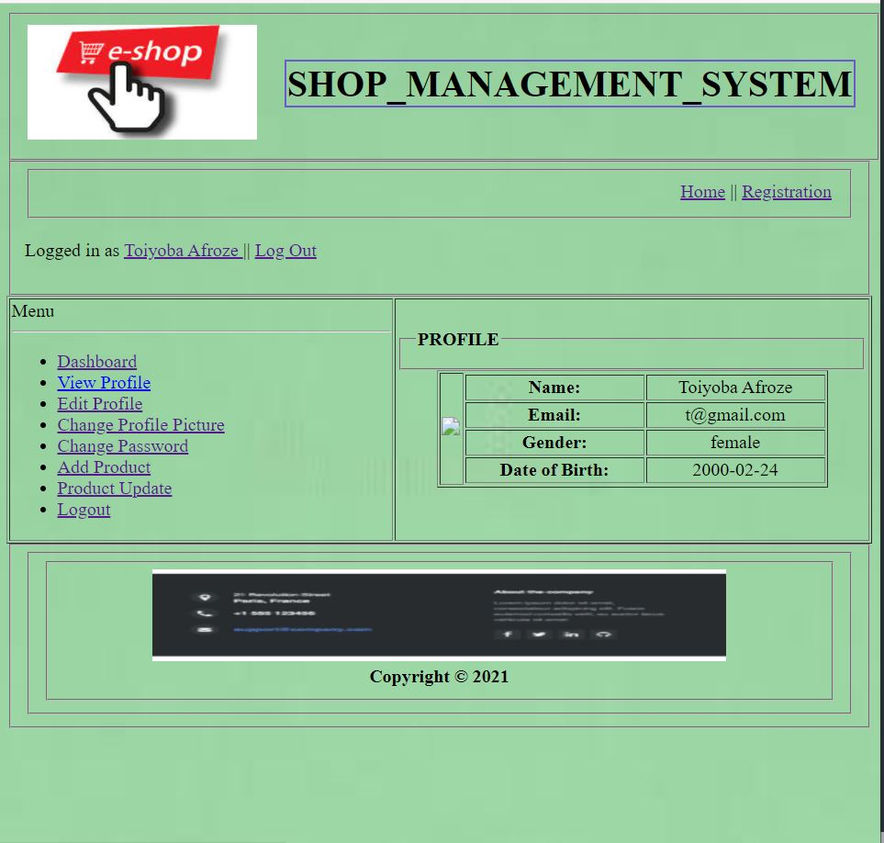

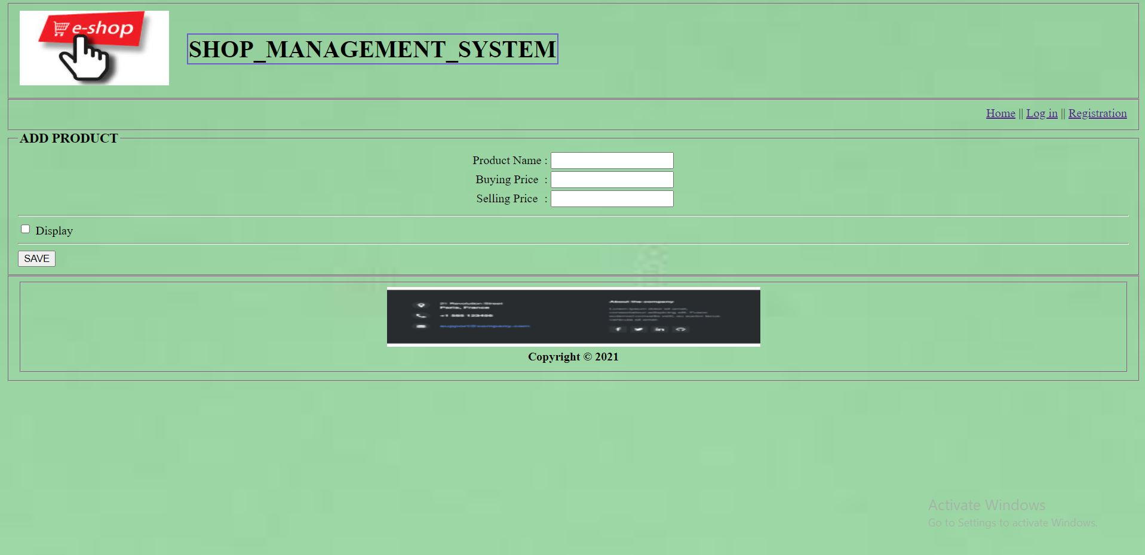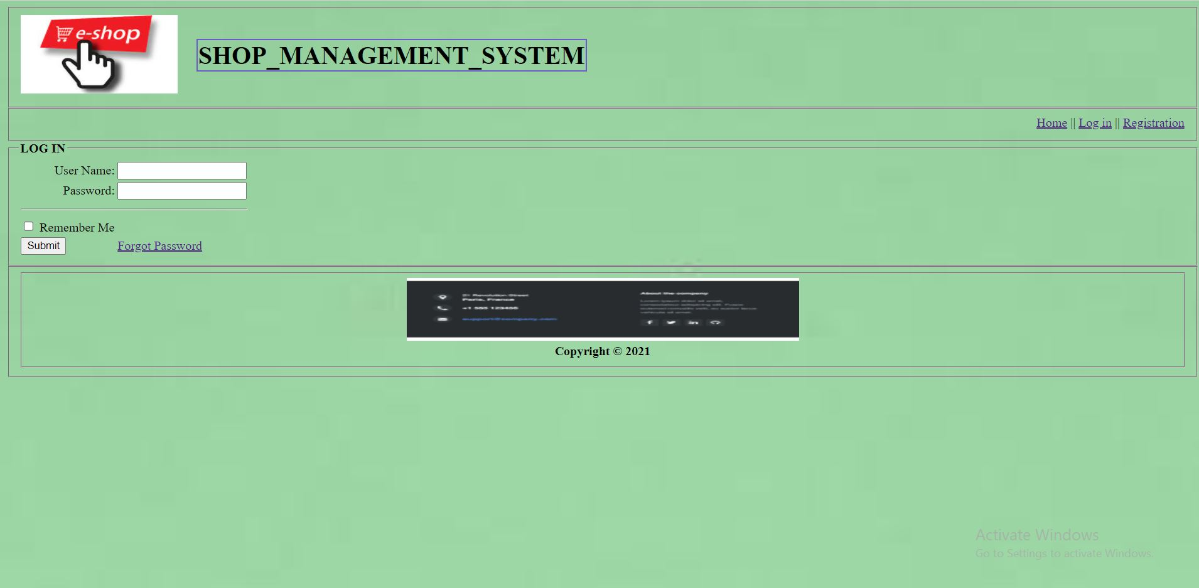

**Impact of this Project:**

We spend our daily time more on the internet for work, study, marketing, business, learning, and entertainment. Now all these commercial and social activities are connected to the internet. And without an E-commerce or E-shop system the world around the internet is impossible and it will scare everyone to imagine. That’s why we are building this project or system to help everyone in modern society so that people can get products or services hasslefree.

People will be benefited by :

1. Saving Time

2. Reducing transport cost

3. Ability to be open 24/7

4. Use electronic payment refers to paperless monetary transactions

5. No more waiting in lines

6. People can search for products and buy those easily.

**Limitations and Possible Future Improvements:**

Limitations:

* No live database
* No active online payment system
* No real customer service
* No inventory yet to sell items.
* No return or exchange policy

Future improvements:

* Apps will be created in future
* Whole work will be done offline that updates automatically in the online system.
* Online payment system can be created

|  |  |  |  |  |  |
| --- | --- | --- | --- | --- | --- |
| CO1.1 and CO2.1 Evaluation: Project Report Evaluation | | | | | |
| Project Proposal  (5) | Background  Study  (5) | Requirement Analysis  (5) | Entity  Diagram  (5) | System Images  against the  Specification (5) | Total (25) |
|  |  |  |  |  |  |
|  | | | | | |